PT 8632
SDI Test Pattern Generator

The PT 8632 Test Pattern Generator can be installed in the PT 5230 Digital Video Generator.

Packing list:
Check that the PT 8632 options package contains the following items:
 | Description: | Item | Quantity
 | Nut for BNC Connector | 2422 034 17419 | 2
 | Lockwasher for BNC Connector | 2422 034 17421 | 2
 | Ribbon Cable with micro 20 pole connectors | 4008 105 04030 | 1
 | Distance Piece M3 | 4008 107 36490 | 8
 | SDI Test Pattern Generator Assy | 4008 109 84800 | 1

The system is “plug and play” meaning that when the unit is mounted no configuration is needed in order to enable the PT 8632.

Installation procedure:
- Open the PT 5230 by removing the top cover.
- Remove the plastic blinds from the back panel for the two SDI output connectors, marked “SDI TPG1”.
- Remove the cable connected to the remote interface board (in the interface board end only).
- Remove the 8 screws placed where the hexagonal spacers are placed on picture page 1. Keep the screws. Install the 8 hexagonal spacers, do not overtighten.
- Place the printed circuit board on the spacers, with the connectors through the back of the generator.
- Mount the lockwasher and nut on the BNC connectors, do not tighten.
- Mount the 8 screws into the spacers, do not tighten.
- Tighten the nuts on the BNC connectors.
- Tighten the 8 screws fixing the printed circuit board to the hexagonal spacers.

- Mount the ribbon cable from the PT 8632 printed circuit board to the PT 5230 main board. Observe that the cable is correctly turned. A guide pin in one end of the connectors should fit into a hole in the PCB.
- Reconnect the cable to the remote interface.
- Mount the top cover on the PT 5230.
- Turn on power, and observe that the menu includes the SDI test pattern generator.
14. Place the option type plate on the side of the generator in order to make later identification possible.
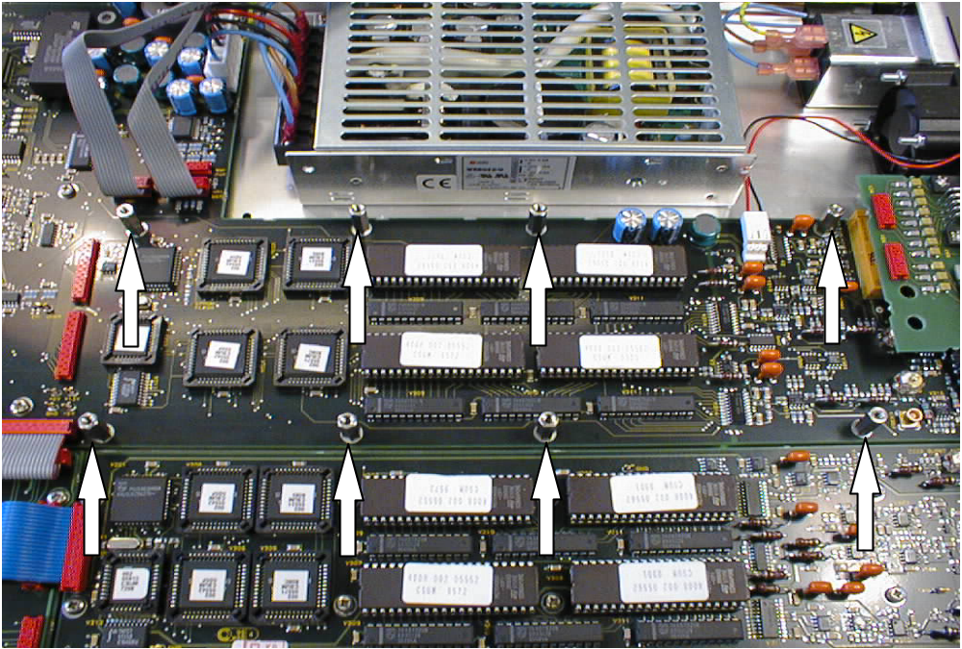

Picture 1

Picture 1: The positioning of the hexagonal spacers. The spacers are placed where the screws have been removed.
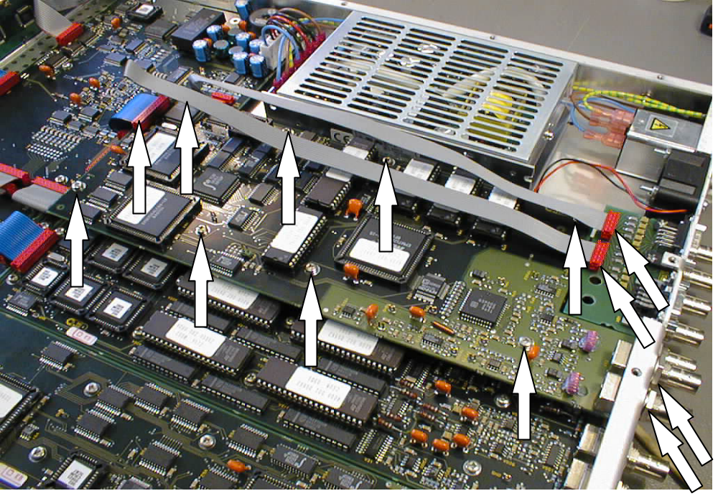
Picture 2.

Picture 2: The final, installed PT 8632 SDI test pattern generator. The arrows indicate positions where work has been done during the installation.

